**CHAPTER 1**

**ABOUT THE ORGANIZATION**

* 1. **INTRODUCTION**



**Xorail** is a leader and preferred provider of Signal, Communications and Positive Train Control Engineering and Design, Systems Integrator, Configuration Management, and Construction Services for the Railroad Industry.  
Xorail is committed to delivering innovation and superior quality.  Xorail combines professionalism, technical competence and experience gained from working with top-notch customers.  Xorail’s focus is on delivering customer-oriented solutions.  Xorail provides best-of-class services to enable Xorail customers to achieve greater levels of quality, efficiency, effectiveness and profitability.Xorail has a proven record of accomplishments in complex projects, and has experience in a wide variety of technologies and platforms.  Xorail is equipped with the best of infrastructure and technology practices, and expertise across heterogeneous technology platforms. Xorail expertises across multi-platform technologies and skill-sets enables us to provide services to a wide spectrum of customers.  Xorail consistently deliver quality services at competitive prices.Xorail’s ability to offer flexible and reliable solutions, within a stringent quality framework and at the right price, has helped build enduring partnerships. “To be a globally respected corporation that provides best-of- breed business solutions;levering technology, delivered by best-in- class people”

* 1. **PRODUCTS**

1. **CABLE REELS:**



**Figure 1:Cabel Reels**

The professional industrial cable reels for the storing and winding of cables for practically every application, indoors as well as outdoors. The unique construction has been designed to maximize safety, electrical as well as mechanical. The integrated mounting bracket facilitates fast and easy mounting. Above this, the high quality standard of all components guarantees high reliability of the reels.

1. **COMPRESSOR:**



**Figure 2:Compressor**

1. Temperature Management System (TMS) to control internal temperature
2. Pulley, shaft, or motor drive
3. Integral cooling fans
4. High efficiency inlet filter
5. Oil sight gage/Oil pressure indicator
6. Rated for continuous or start/stop operation
7. Rated speed: 1000 RPM
8. Rated pressure: 140 psi
9. Displacement at rated speed: 153.5 CFM
10. 40 HP at rated speed and pressure

# CYLINDER AIR COOLED COMPRESSOR :



**Figure 3:Cylinder air cooled compressor**

Offering a complete line of air-cooled, water-cooled, and rotary compressors, Wabtec provides original equipment and can rebuild main line reciprocating compressors.

1. Pulley shaft or motor drive
2. Single or dual speed motor drive
3. Various motor voltages available
4. Stainless steel braided unloader tubing
5. Rated for continuous or start/stop operation
6. Stand alone or palletized
7. 1100 RPM rated speed; 140 psi rated pressure
8. Displacement at rated speed: 247.5 CFM
9. 60 HP at rated speed and pressure
   1. **SERVICES**

# BOGIE / CASTING OVERHAUL :



**Figure 4:Casting Overhaul**

Wabtec Rail undertakes the overhaul, refurbishment and conversion of all types of locomotive, passenger rolling stock and freight wagon bogies. Xorail is able to offer its customers a fully comprehensive service with the overhaul of the wheelsets, brake equipment, suspension systems and dampers undertaken in-house at Xorail’s works. Xorail is able to undertake the repair of damaged and fractured bogie frames. Xorail’s workshops are fully equipped for carrying out shot blasting, non-destructive testing and repainting of bogies.

# COMMUNICATION SERVICES :

Xorail’s System Integration & Communications Group delivers seamless integration across cutting-edge voice & data communications systems, signaling systems, grade crossings, and train control & dispatch systems.Xorail’s signaling background enables us to do more for you, from conceptual design and communications architecture, to detailed plans, procurement, project management, testing, integration, commissioning, and full documentation.

# CONSTRUCTION SERVICES:

Xorail’s experienced construction teams can provide installation of your highway crossing or wayside signal project with on-site support personnel for in-service testing of equipment.

**CHAPTER 2**

**ABOUT THE DEPARTMENT**

**2.1 DATA ANALYTIC**

Data analysis is a process of inspecting, [cleansing](https://en.wikipedia.org/wiki/Data_cleansing), [transforming](https://en.wikipedia.org/wiki/Data_transformation), and [modeling](https://en.wikipedia.org/wiki/Data_modeling) [data](https://en.wikipedia.org/wiki/Data) with the goal of discovering useful information, informing conclusions, and supporting decision-making. Data analysis has multiple facets and approaches, encompassing diverse techniques under a variety of names, and is used in different business, science, and social science domains. In today's business world, data analysis plays a role in making decisions more scientific and helping businesses operate more effectively.

[Data mining](https://en.wikipedia.org/wiki/Data_mining) is a particular data analysis technique that focuses on modeling and knowledge discovery for predictive rather than purely descriptive purposes, while [business intelligence](https://en.wikipedia.org/wiki/Business_intelligence) covers data analysis that relies heavily on aggregation, focusing mainly on business information. In statistical applications, data analysis can be divided into [descriptive statistics](https://en.wikipedia.org/wiki/Descriptive_statistics), [exploratory data analysis](https://en.wikipedia.org/wiki/Exploratory_data_analysis) (EDA), and [confirmatory data analysis](https://en.wikipedia.org/wiki/Statistical_hypothesis_testing) (CDA). EDA focuses on discovering new features in the data while CDA focuses on confirming or falsifying existing [hypotheses](https://en.wikipedia.org/wiki/Hypotheses). [Predictive analytics](https://en.wikipedia.org/wiki/Predictive_analytics) focuses on application of statistical models for predictive forecasting or classification, while [text analytics](https://en.wikipedia.org/wiki/Text_analytics) applies statistical, linguistic, and structural techniques to extract and classify information from textual sources, a species of [unstructured data](https://en.wikipedia.org/wiki/Unstructured_data). All of the above are varieties of data analysis.

[Data integration](https://en.wikipedia.org/wiki/Data_integration) is a precursor to data analysis,and data analysis is closely linkedto [data visualization](https://en.wikipedia.org/wiki/Data_visualization) and data dissemination. The term *data analysis* is sometimes used as a synonym for data modeling.

**2.2 WEB DESIGNING**

Web design encompasses many different skills and disciplines in the production and maintenance of websites. The different areas of web design include web graphic design; [interface design](https://en.wikipedia.org/wiki/Interface_design); authoring, including standardised code and [proprietary software](https://en.wikipedia.org/wiki/Proprietary_software); [user experience design](https://en.wikipedia.org/wiki/User_experience_design); and [search engine optimization](https://en.wikipedia.org/wiki/Search_engine_optimization). Often many individuals will work in teams covering different aspects of the design process, although some designers will cover them all. The term web design is normally used to describe the design process relating to the front-end (client side) design of a website including writing [markup](https://en.wikipedia.org/wiki/Markup_language). Web design partially overlaps [web engineering](https://en.wikipedia.org/wiki/Web_engineering) in the broader scope of [web development](https://en.wikipedia.org/wiki/Web_development). Web designers are expected to have an awareness of [usability](https://en.wikipedia.org/wiki/Web_usability) and if their role involves creating markup then they are also expected to be up to date with [web accessibility](https://en.wikipedia.org/wiki/Web_accessibility) guidelines.

Web designers use a variety of different tools depending on what part of the production process they are involved in. These tools are updated over time by newer standards and software but the principles behind them remain the same. Web designers use both [vector](https://en.wikipedia.org/wiki/Vector_graphics_editor) and [raster](https://en.wikipedia.org/wiki/Raster_graphics_editor) graphics editors to create web-formatted imagery or design prototypes. Technologies used to create websites include W3C standards like HTML and CSS, which can be hand-coded or generated by [WYSIWYG editing software](https://en.wikipedia.org/wiki/Website_builder). Other tools web designers might use include mark up [validators](https://en.wikipedia.org/wiki/HTML_validator) and other testing tools for usability and accessibility to ensure their websites meet web accessibility guidelines.

* 1. **How Data Analytic will help Business Grow**

**1) Analysis of business value Chain :**

There are companies that’ll help you in finding the insights of the value chains that are already there in your organisation and his is going to be done through data analytics. So, the analytics will tell how the existing information is going to aid the business in finding out the gold mine that is the way to success for a company.

**2) Industry knowledge :**

Industry knowledge is another thing that you’ll be able to comprehend once you get into data analytics, it is going to show how you can go about your business in the near future and what is that the economy already has its hands on. That’s how you are going to avail the benefit before anyone else.

**3) Seeing the opportunities :**

As the economy keeps on changing and keeping pace with the dynamic trends is very important but at the same time profit making is one thing that an organisation would most of the time aim for, Data Analytics gives us analysed data that helps us in seeing opportunities before the time that’s another way of unlocking more option.

**CHAPTER 3**

**PROJECT DESCRIPTION**

**3.1 INTRODUCTION**

Data Science is the process of analyzing data using specialized skills and technology whereas Web Development is the creation of a website for the internet or intranet using company details, client requirement, and technical skills like any other software application, even in a web application, a good UI design is extremely important to provide the right user experience.

There are different softwares available for developing web applications-for example Adobe Dreamweaver, WordPress, Visualstudio, etc. One that is popular is Visual Studio because it provides multiple features that makes application development easy.

Microsoft Visual Studio is an integrated development environment (IDE) from Microsoft. It is used to develop computer programs, as well as websites, web apps, web services. Visual Studio uses Microsoft software development platforms such as Windows API, Windows Forms, Windows Presentation Foundation, Windows Store and Microsoft Silverlight. It can produce both native code and managed code.

Following are some of the features provided by Visual Studio:

* Support for creating SharePoint applications.
* UML Designer.
* Enhanced support for multi-targeting.
* Support for parallel programming and debugging.
* Pin watch variables, pinning a variable allows you to observe how the variable’s value changes as you step through the code.
* Better Multiple Monitor Support.
* Custom Window Layouts.

# PROBLEM STATEMENT

Build a web application that provides an option to upload an excel page, then process those data in the excel pages and provide utilization rate, efficiency and productivity rate.

* 1. **PROBLEM ANALYSIS**

Problem analysis is a set of analytic tasks meant to increase the designers understanding of an unbalanced situation, for the sake of designing a change to the situation that will have better balance.Hence the first step to be followed is problem analysis .The steps followed to reach the given problem statement defines problem analysis.The excel sheet was analysed first to understand the different kinds and types of data available and which data must be extracted to compute the results then once the data is extracted it is uploaded to the database and the respective formulas can be applied on the data to get the required result.

* 1. **IMPLEMENTATION**

Web development broadly refers to the tasks associated with developing websites for hosting via internet or intranet. The web development process includes web design, web content development, client-side/server-side scripting and network security configuration, among other tasks. In order to develop these Web applications, there is a software available called the Visual Studio. The Visual Studio includes a comprehensive set of development tools such as a [debugger,](https://en.wikipedia.org/wiki/Debugger) [libraries,](https://en.wikipedia.org/wiki/Software_library) documentation, sample code, and tutorials. The development platforms are supported by computers running Linux, Mac OS and Windows. The Visual studio supports programming in many languages such as Java, C++, C#.

SQL server Management Studio(SSMS) is a software application first launched with Microsoft SQL server that is used for configuring, managing, and administering all components within Microsoft SQL Server. The tool includes both script editors and graphical tools which work with objects and features of the server. A central feature of SSMS is the Object Explorer which allows the user to browse, select, and act upon any of the objects within the server.

Following are the steps to create a Web Application:

1. Start the Microsoft SQL server Management Studio, specify the server name then click on connect.

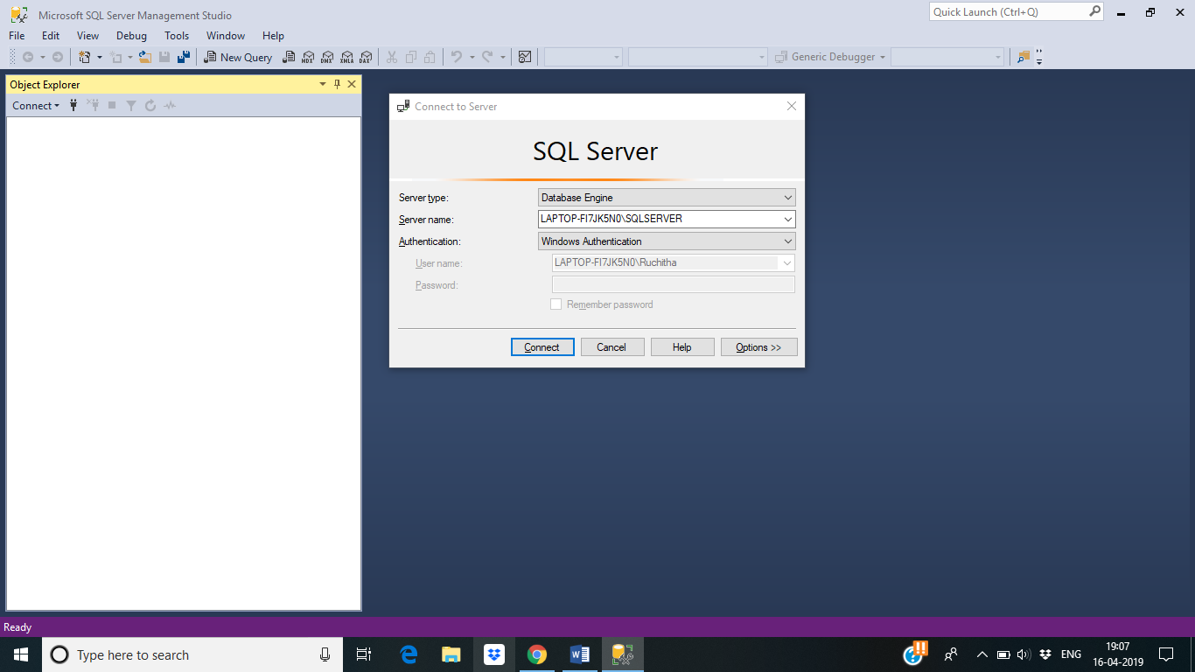

**Figure 3.1: SQL Server Authentication**

1. Database→ Create New Database. A new window appears in which database Name has to be specified. Then click on OK.

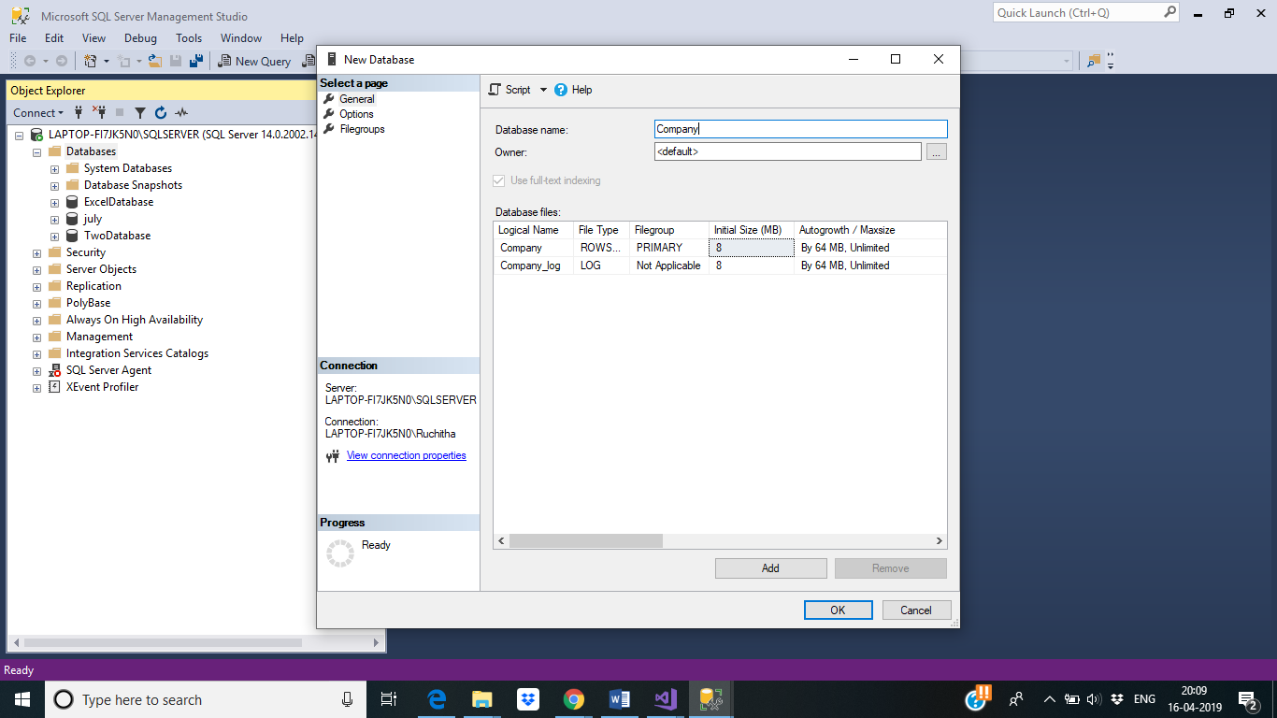

**Figure 3.2: Create New Database**

1. Company database→ Tables→ New Table. Add required columns then save.

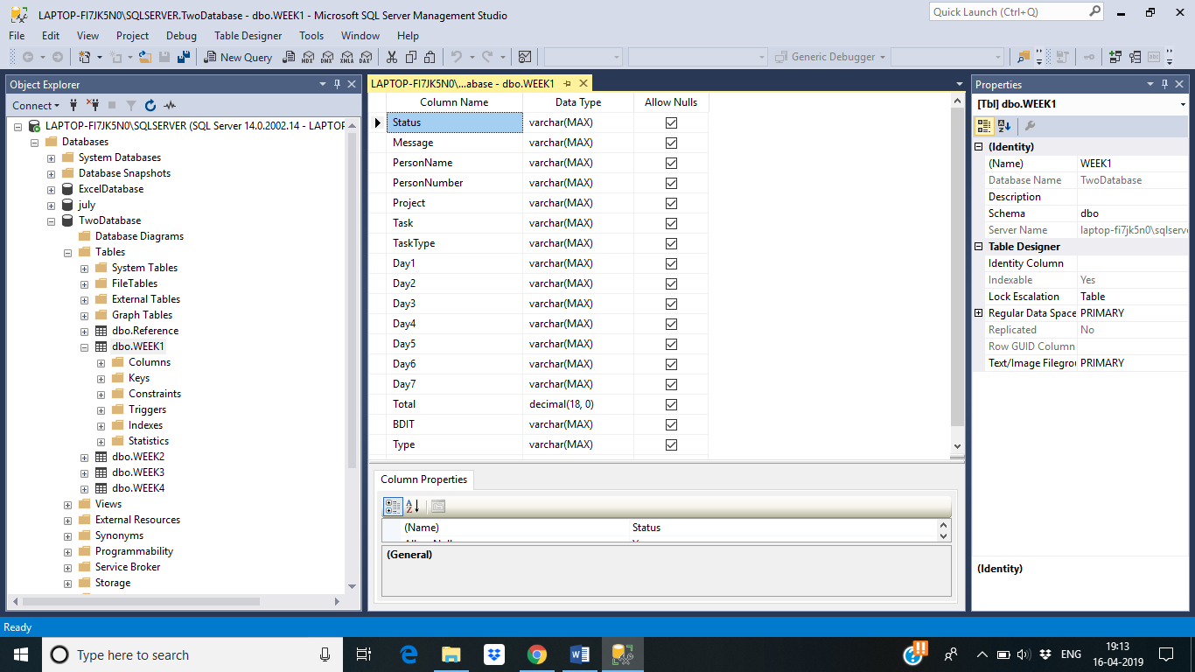

**Figure 3.3:Creation of Tables**

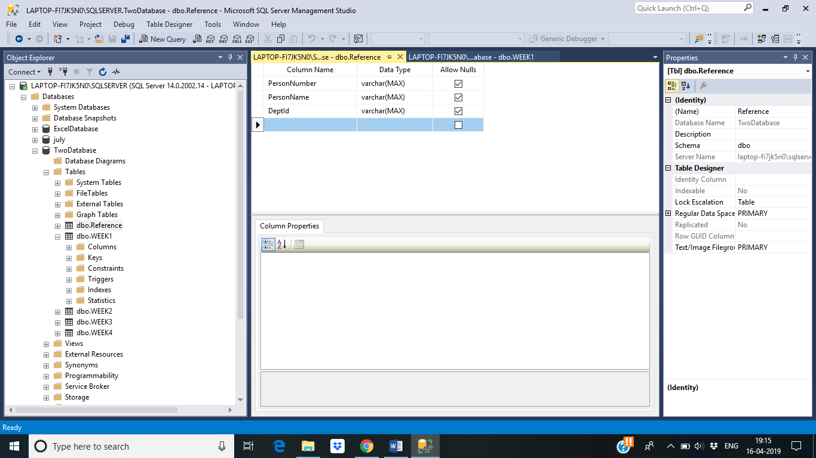

**Figure 3.4: Creation of Tables**

1. Run the Visual studio, File→ New→ Visual c#→ Core Web Application, Specify the name of the project then click on OK.

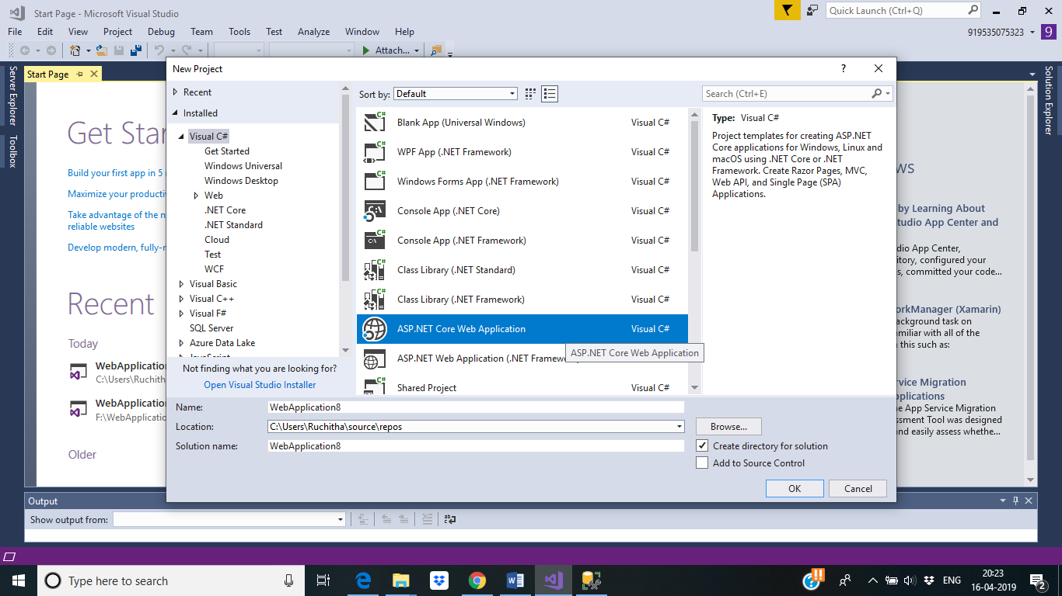

**Figure 3.5: Creating a New Project in Visual Studio**

1. Connect to the Database in Sql Server Management, by specying the server and database name.

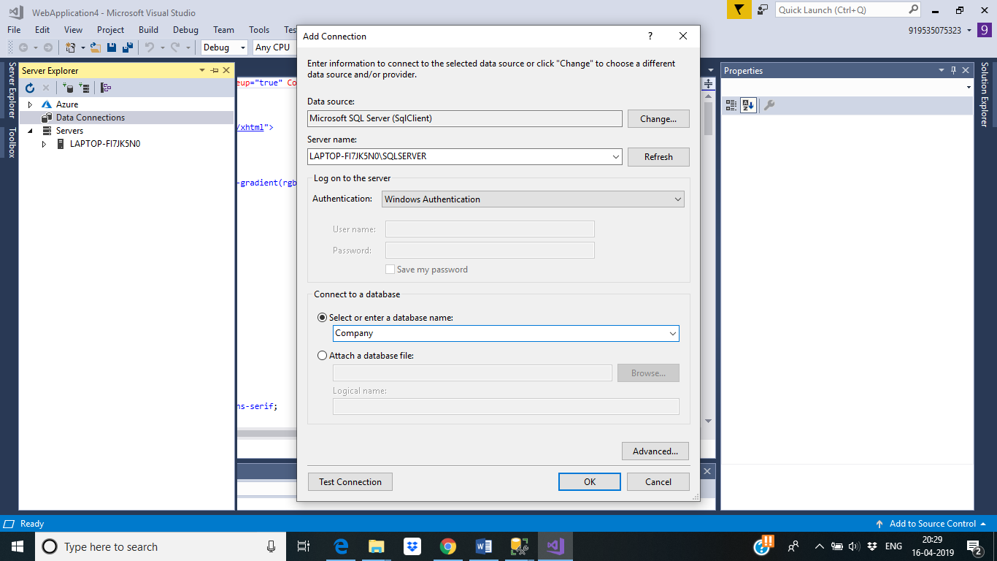

**Figure 3.6: Connecting to the database**

1. Project→ Add new Item→ Choose Web Form, to create the webforms.

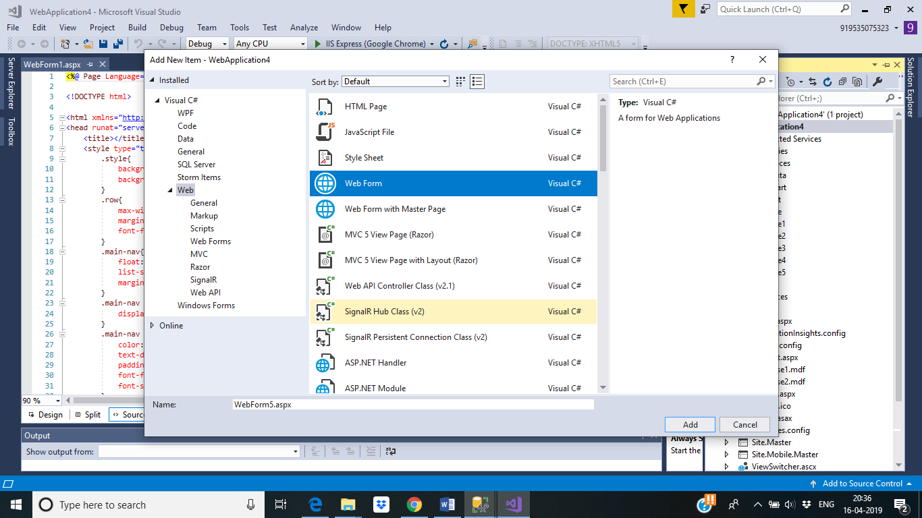**Figure 3.7: Creating a Web Forms in a Project.**

To run an application in visual studio:

1. Select the Buil option on the menu bar and click on Build Solution to start the application build.
2. Click on the IIS Express on successful build.

Each page of the web application is designed in the XML file that is created for each web from in the project. Either the components are dragged and dropped into the design layout or commands for each component is typed in the XML file.

The design layout which is initially mentioned in the XML file will act as the container consisting of various components that make up the application. Some of the design layouts available are ConstraintLayout, RelativeLayout and LinearLayout.In the ConstraintLayout, the components are constrained manually by the user for each component that is included in the page. In the RelativeLayout and LinearLayout, commands such as margin (top, bottom, left, right), padding etc., are used for constraining the components.

* 1. **RESULTS**

**Web Application**

This section shows the results of the work done during the internship project. Design of an application was the main task performed during this internship project. Various components provided by Visual studio such as textview, plain text, password, buttons, etc., are used by this Web application

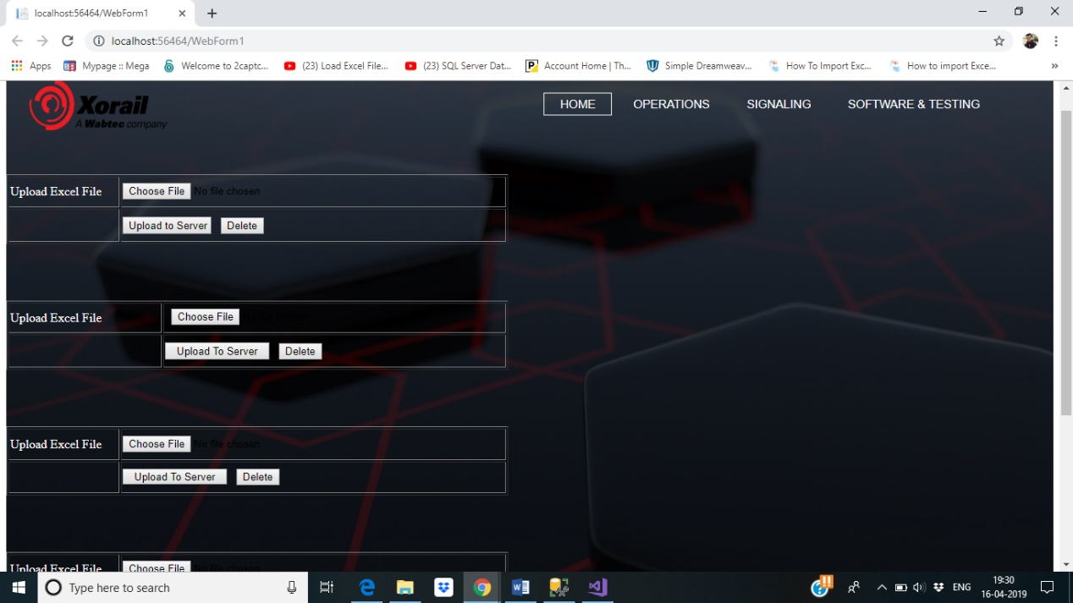

FF F

**Figure 3.8: Home Page to upload all the excel sheets.**

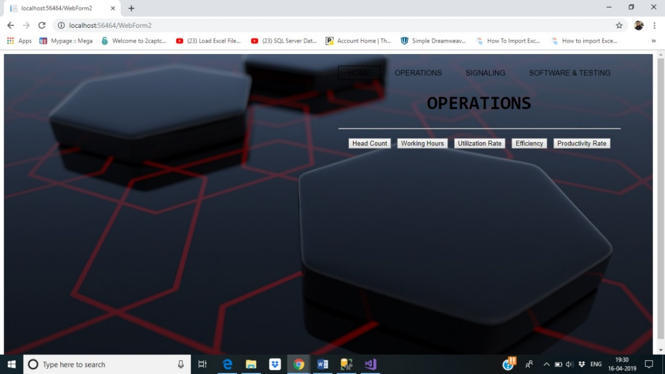

**Figure 3.9: Operations Department Page**

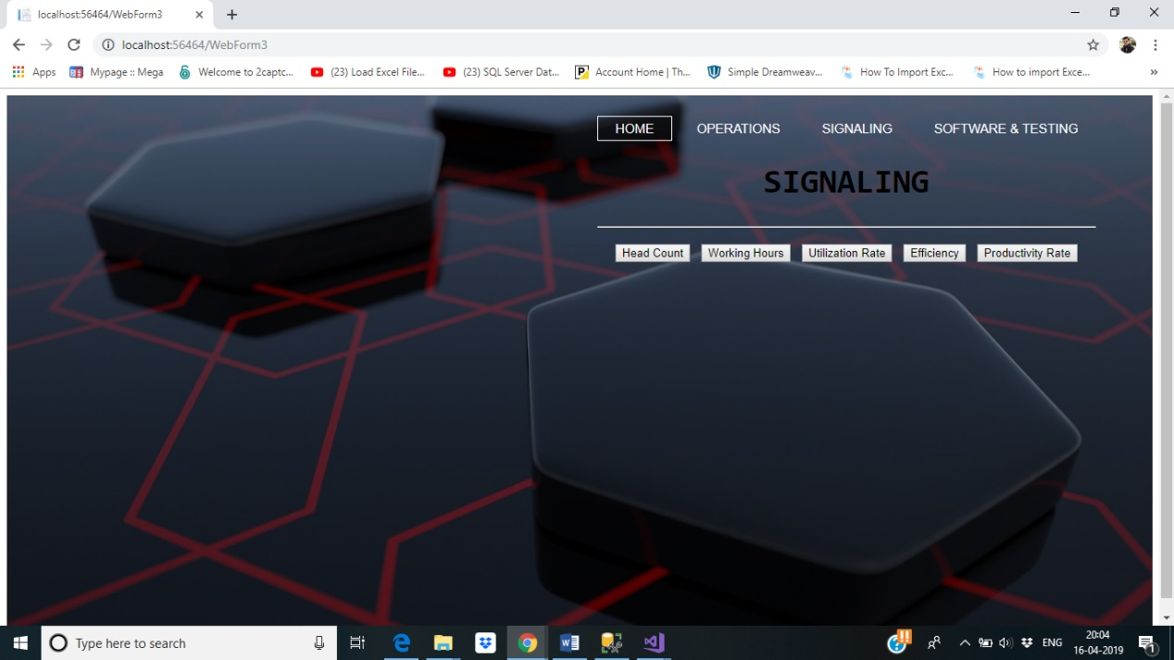

**Figure 3.10: Signaling Department Page**

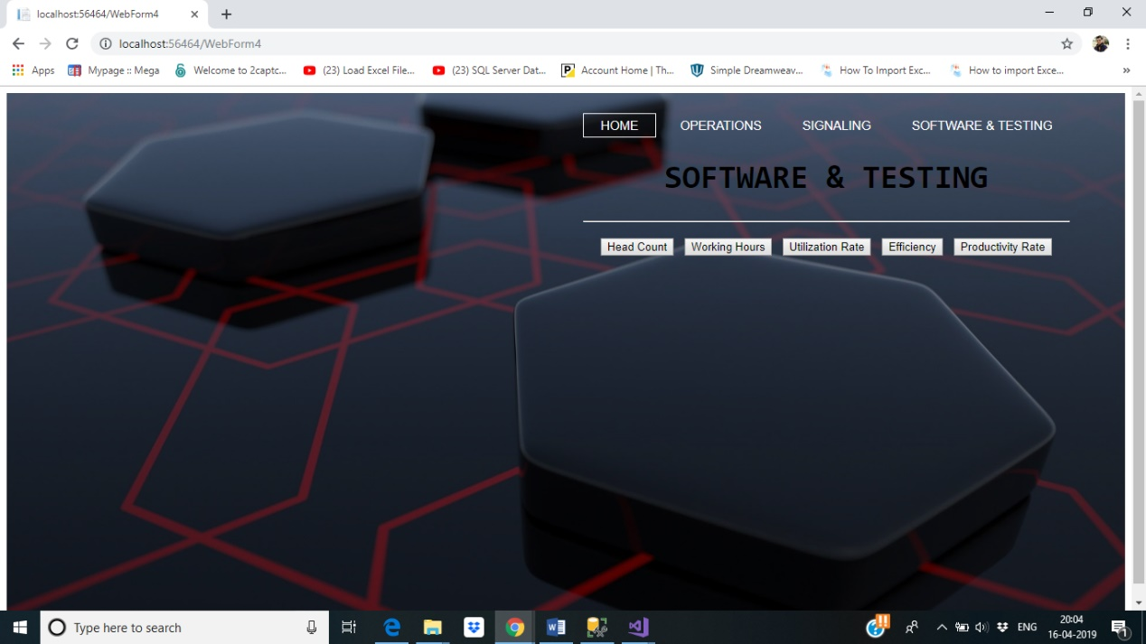

**Figure 3.11: Software and Testing Department Page.**

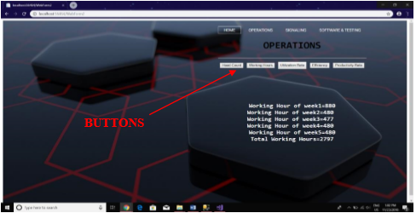

## **Figure 3.12: Displaying the total working hours of operation department.**

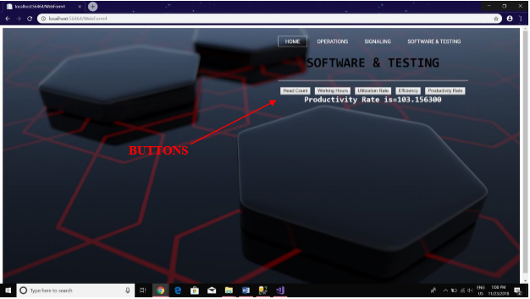

**Figure 3.13: Displaying the Productivity rate of software and testing department.**

**CHAPTER 4**

**REFLECTION NOTES**

During my work experience at Xorail A Wabtec Company , I was fortunate enough to have experienced firsthand and learned, many different sides of what goes into a project, the general process of how a project is initially planned, developed and completed; as well as how much work and detail goes into every stage. Another valuable lesson I have learned during these 8 weeks, were the many different types of work an Engineer has to perform, which in turn, have provided me with more insight into the different types of roles and responsibilities that I could perform, as a Computer Science Engineer.

My confidence grew rather quickly when I realized that I could contribute to these processes and better the projects. After I created the project management plan I held a meeting to go over what I created with the project team. After everyone reviewed the document I received a great deal of positive feedback. Everyone on the team, liked the completeness of the document, and the direction the document would take the project.

I was exposed to a variety of work related to the professional courses at college and I have no doubt that it will be significant in my future professional career.

Overall I think the internship was a great experience that opened my eyes to some situations and processes that I was unaware of. I feel like the classes that I took did a great job in preparing me to step into a project management position and excel in it.

In this regard, I would like to whole heartedly thank the organization for accepting me as an intern and myinstitution, Global Academy of Technology for giving the opportunity to do this internship.

**CONCLUSION**

Data analysis is important in business to understand problems facing an organisation, and to explore data in meaningful ways. Data in itself is merely facts and figures. Data analysis organises, interprets, structures and presents the data into useful information that provides context for the data. This context can then be used by decision-makers to take action with the aim of enhancing productivity and business gain or organisation gain.

Handling data is one of the important and difficult tasks these days .It is very much important to see trough it that data is handeled properly and accurately.Hence performing data analytics was very much helpful for the company as well as the development team.

Web development services help your company to increase product knowledge, maintain communication between you and potential clients, sell your products or services, generate leads for the business, and increase the popularity of your company and much more.

Web Developmen has emerged as an industry in the last decade. In the field of website development, a company or a person develops web sites to be placed on the World Wide Web. The number of websites on the web are increasing at a very fast pace. The web developers and web designers make a good amount of money while constructing these web sites. Web development is a field which can pay you a lot if you are interested in taking it seriously. At present the number of web sites on the web is in millions.

Due to the increase of the demand for web sites and web development this internship provided a platform for us to learn new concepts and enhance in it.

**REFERENCES**

[1] www.w3schools.com

[2] https://www.c-sharpcorner.com/

[3] https://visualstudio.microsoft.com/vs/express/

[4]https://www.tutorialspoint.com/ms_sql_server/ms_sql_server_management_studio.htm

[5] https://stackoverflow.com